**Connecting to the edit share admin page**

On Mac – select **Go** from the finder menu and **Connect To Server** from the dropdown

Type in:

**vnc://editshare.hallam.shu.ac.uk**

Password: !1Mw2mw2mam

Close any windows that are open and you should see a screen that looks like the below:

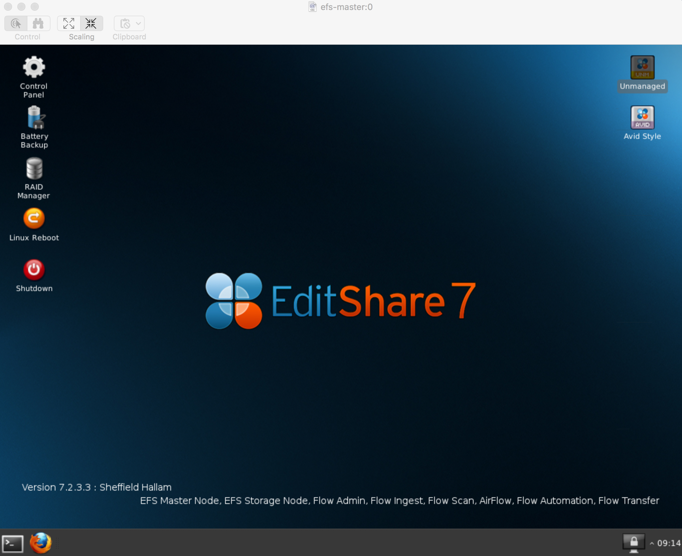

For any workspaces etc. involving Avid Media Composer you need to double click the Avid Style icon and setup work spaces in this app.

For any workspaces that are not avid specific then double click the unmanaged icon and setup works spaces in this app.

Login with username: **editshare**

Password: !1Mw2mw2mam

**Adding a User to Connect 2:**

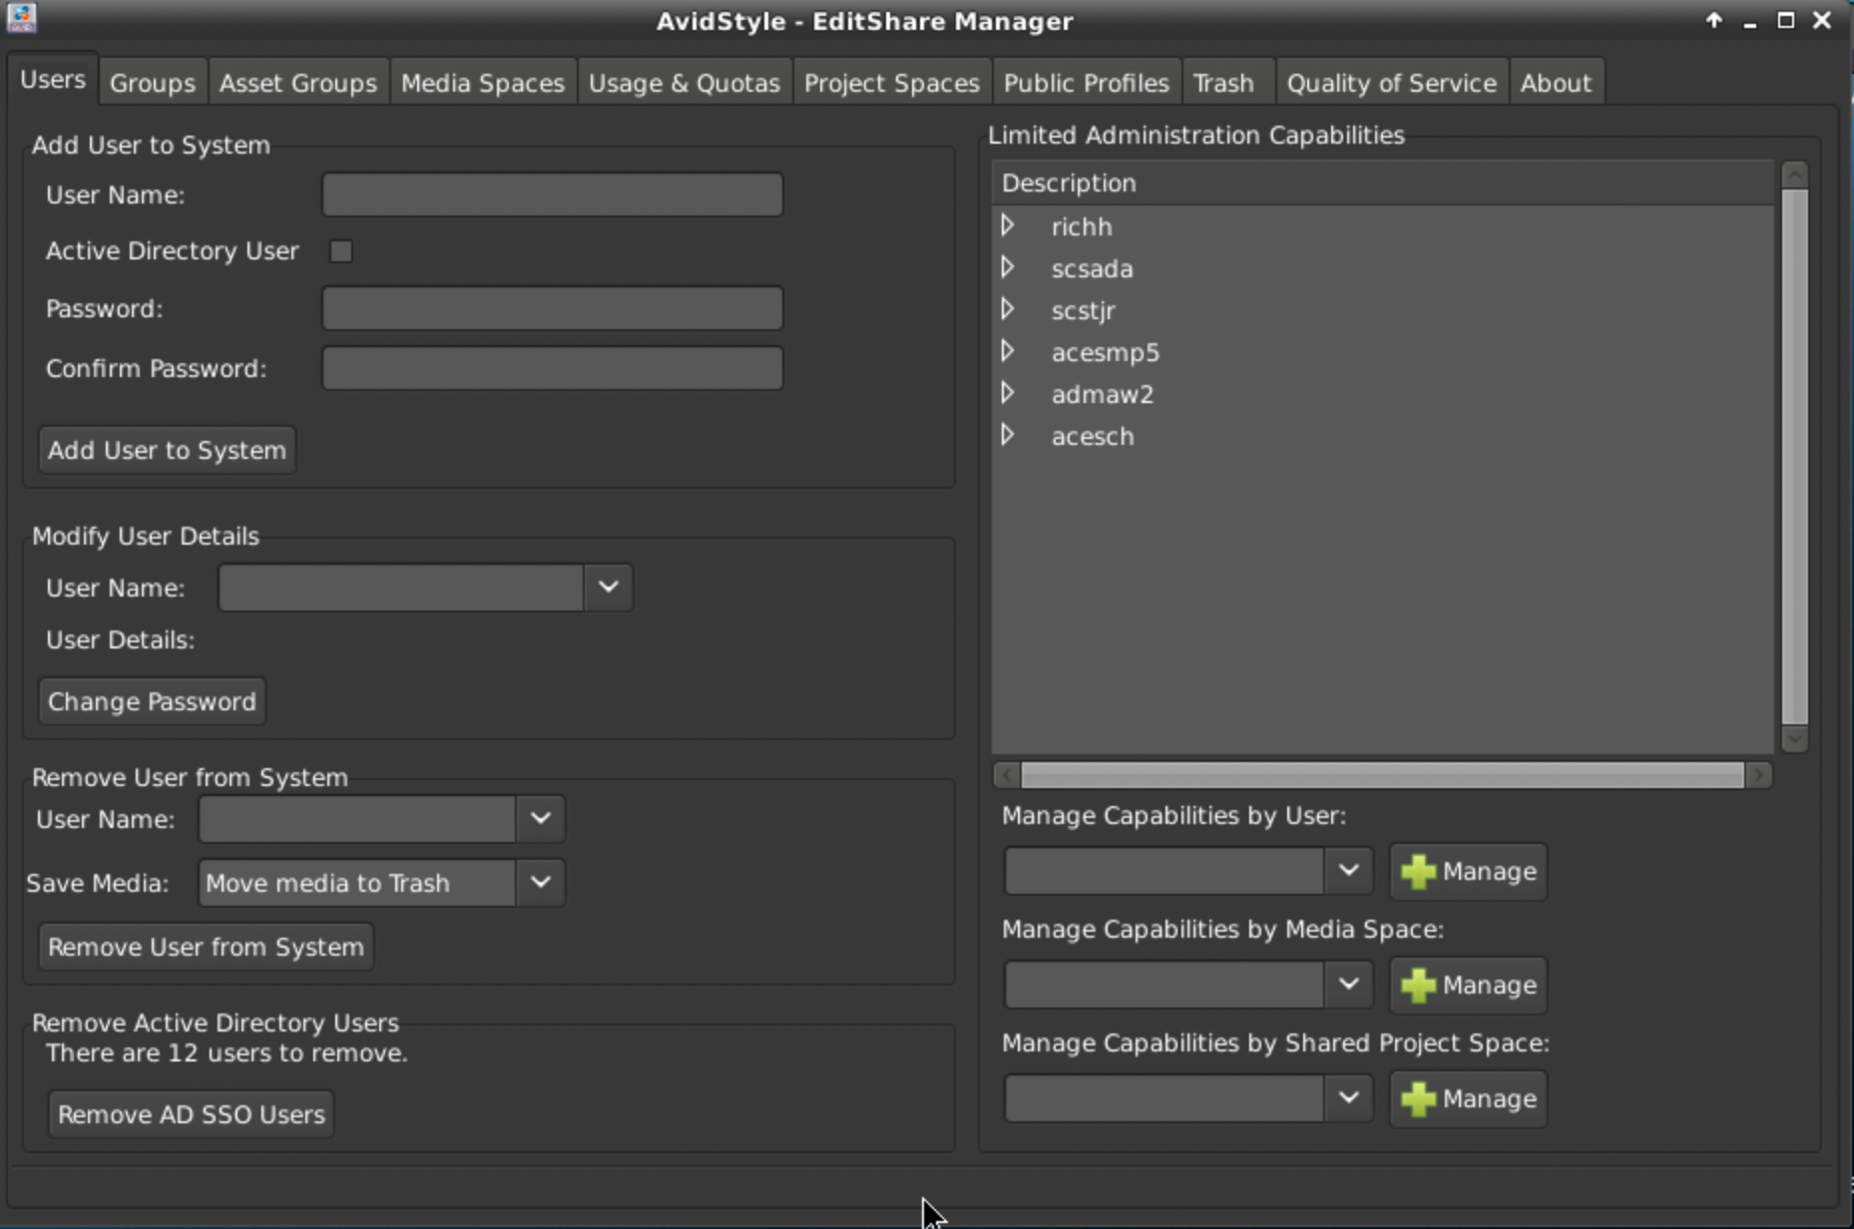

DTS should mass import new students at the start of the year and assign them into year groups – this should be requested thru it help (as a reminder) in August.

If any users have been missed out then in the Users tab under the Add User to System section type in the username and click the active directory user tick box. Then click add user to system – some dialogue will appear at the bottom of the screen to let you know if this has been successful or if the user already exists.

**Adding a user to a group**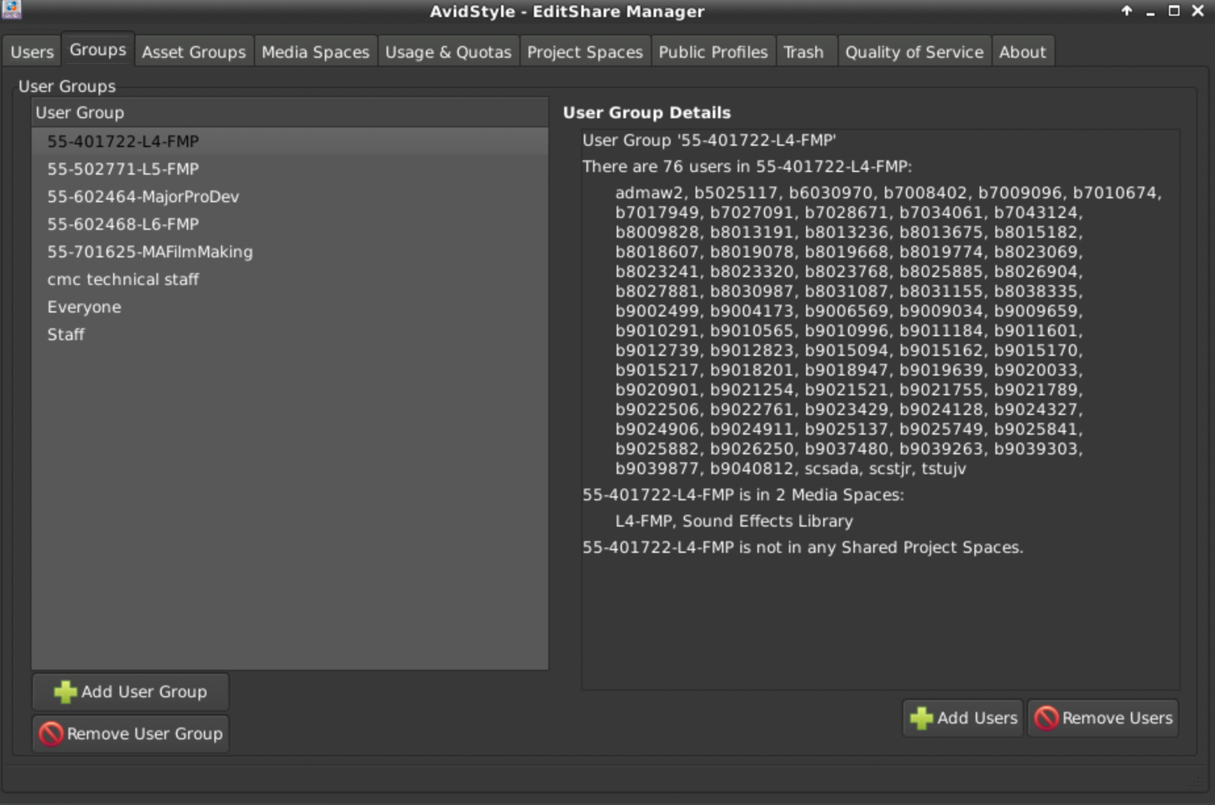

Click the **add users** button then just click a tick box to add a user to the group finally clicking **modify membership** when completed.

**Add Users or Groups to Media Space**

Choose the media space name from the drop down list then select the user or group name you wish to add from the drop down list – click the add User or Group to Media Space Button

**Remove Users or groups from media space**

As per above using the Remove users or Groups from Media Space

